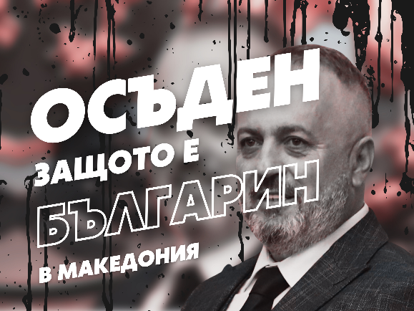 **P U B L I C A P P E A L**

**by**

**Initiative Committee in support**

**of Mr. Ljupcho Georgievski and the Bulgarian Cultural Club**

**led by him in the town of Bitola, Republic of North Macedonia**

**Ladies and gentlemen, brothers and sisters Bulgarians,**

Over the past few years, the Bulgarian public has been alarmed by the fierce persecution of Bulgarians in the Republic of North Macedonia. We strongly condemn the administrative and political pressure exerted by the authorities in our neighbouring country on all those citizens with Bulgarian identity and the Bulgarian associations that have been established there. We stand in defence of the Bulgarians living in the Republic of North Macedonia who by legal means and in a peaceful manner are trying to present to the local society the personalities and events of our common history, to defend the rights of the Bulgarian population and to support the efforts to improve the relations between our two countries.

Particularly striking was the last case (June 2025) with the sentencing by the court in the Republic of North Macedonia to one year in prison suspended of Mr. Ljupcho Georgievski, the chairman of the now banned by law "Ivan Mihailov" Cultural Club in the town of Bitola. This is a shameful sentence based on ethnic hatred in a country that claims EU membership.

We just want to remind you that the club was set on fire in 2022 and Mr. Georgievski himself was fired last year. Similar is the fate of a number of other Club members, some of whom were forced to leave the Republic of North Macedonia and seek work in Bulgaria and EU countries to provide for their families.

The work of the members of the Club is extremely difficult as they are mistreated and restricted by the North Macedonian authorities. The Club itself, after several refusals for court registration because the North Macedonian rulers found all its names inappropriate, is now registered under the name “Edna rosa” (One Rose).

The most active Bulgarian cultural organization in the Republic of North Macedonia is facing extreme financial difficulties to develop its patriotic and noble activities.

Therefore, we hereby appeal to the Bulgarian public, institutions and private business to support the activities of this Bulgarian association in the Republic of North Macedonia and its president Mr. Ljupcho Georgievski. We call on all Bulgarians, here in Bulgaria and around the world, to support the Bulgarian cultural centre "Edna Rosa" in the town of Bitola. The money raised will enable the normal functioning of a cultural institution of the Bulgarians in the Republic of North Macedonia. The Bulgarian people should help their brothers to show what were the spiritual heights and achievements of the Bulgarians in this region. And to preserve and strengthen their ties with mother Bulgaria.

Not only the financial means that can be raised are important, but even more important is the gesture of empathy towards our compatriots in the Republic of North Macedonia. Let them feel that the citizens of a free and European Bulgaria have not forgotten them. Today, Bulgarian society stands up in defence of its brothers - Bulgarians who are subjected to violence and insults, who are marginalised and satanised, persecuted and judged in their native places in the state of the Republic of North Macedonia.

Sofia, 24 June 2025

Faithfully yours:

Acad. Georgi Markov

Acad. Vasil Gyuzelev

Acad. Vassil Nikolov

Acad. Ivan Granitski

Prof. Georgi Nikolov - Chairman of the Macedonian Scientific Institute

Assoc. Prof. Alexander Grebenarov – IHS

Assoc. Prof. Dr. Milen Mihov, “St. Cyril and St. Methodius” University of Veliko Tarnovo

Vladimir Mitov - Scientific Secretary of MSI

Blagoy Shatorov - Secretary of the closed down Bulgarian Club "Ivan Mihailov" in Bitola…

Monetary amounts in any currency can be transferred to the bank account of the “Edna Rosa” Association:

IBAN: MK240150118761341

BANK: Universal Investment bank Skopie /UNIBANK/ AD;

SWIFT: UIBMMK22XXX

Културен центар „Една роза“ Битола

Scientists who have supported the Public Appeal:

акад. Ячко Иванов, член-кор. Николай Цанков, член-кор. Георги Михов, акад. Христо Белоев, член-кор. Атанас Семов, член-кор. Алберт Кръстанов, акад. Иван Русчев, акад. К. Хаджииванов, член-кор. Иван Атанасов, акад. Иван Юхновски, акад. Кирил Боянов, член-кор. Венелин Живков, акад. Петър Попиванов, акад. Иван Илиев, член-кор. Даниела Йорданова, акад. Богдан Петрунов, член-кор. Виолета Великова, член-кор. Петър Петров, член-кор. Георги Георгиев, член-кор. Стойчо Язаджиев, член-кор. Надежда Рибарска, акад. Петко Петков, член-кор. Стефан Костянев, член-кор.Владимир Божинов, акад. Румен Панков, акад. Александър Драйшу, член-кор. Илия Цачев, акад. Илза Пъжева, акад. Тони Спасов, член-кор. Илия Рашков, член-кор. Костадин Ганев, акад. Христо Цветанов, член-кор. Николай Николов, акад. С. Троянски, акад. Иван Загорчев, акад. П. Атанасов, член-кор. Станислав Василев, акад. Васил Големански, член-кор. Николай Бонев, акад. П. Атанасов, акад. Светлана Куюмджиева, акад. Олег Мушкаров, член-кор. Христина Групчева, акад. Красимир Атанасов, член-кор. Георги Тодоров, член-кор. Петър Бойваленков, акад. Стефан Иванов, член-кор. Иван Русев, акад. Станимир Троянски, член-кор. Стефан Хаджитодоров, акад. Веселин Дренски, член-кор. Емил Нисимов, член-кор. Валентина Петкова, акад. Иван Илчев, член-кор. Светозар Маргенов, член-кор.Иво Петров, акад. Вася Банкова, член-кор. Стефан Хаджитодоров, проф. Стефан Драгоев, член-кор. Ангел Стефанов, акад. Ивеан Попчев, акад. Владимир Овчаров, чл.-кор. Лозан Спасов, чл.-кор. Димитър Иванов, чл.-кор. Теодора Димова, акад. Тони Спасов, чл-.кор. Екатерина Бъчварова, акад. Никола Съботинов, чл.-кор. Александър Костов, чл.-кор. Младен Савов